Governor Stirling Senior High School
Year 12 Physics
Task 4A: Investigation – Circular Motion

PRACTICAL ASSESSMENT Part 1
CIRCULAR MOTION

NAME: ______________________________

An excellent Willetton High physics student conducted an experiment investigating circular motion.
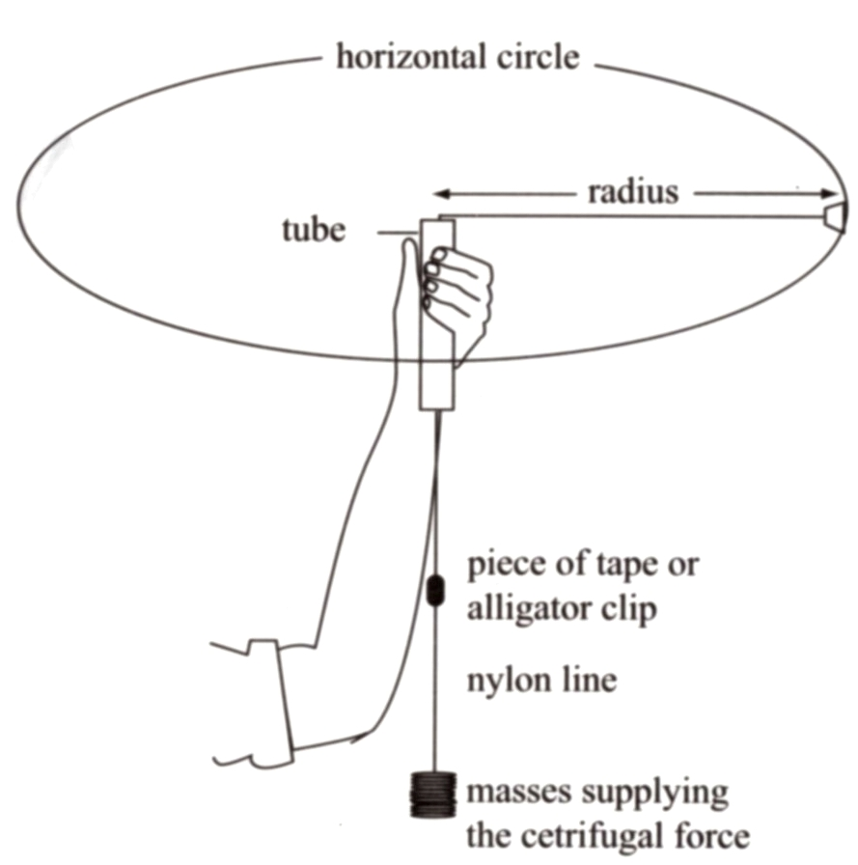

Rubber stopper

Masses supplying the centripetal force (F_{c})

The stopper was whirled in a circle, and the radius of the circle was kept at a constant value
of: 0.600 m

The results obtained were as follows:
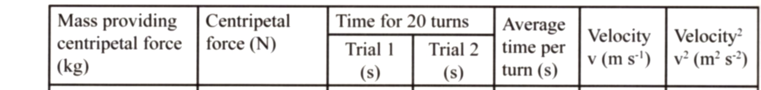

0.200 15.2 15.1

0.250 14.2 13.1

0.300 12.9 11.7

0.400 10.8 10.3

0.450 10.1 10.2

1.0 Complete the table of results. (2 marks)

- On the graph paper provided, plot the data of force versus velocity squared. (3 marks)



- Use this graph to determine the mass of the rubber stopper (4 marks)
(Show working here.)

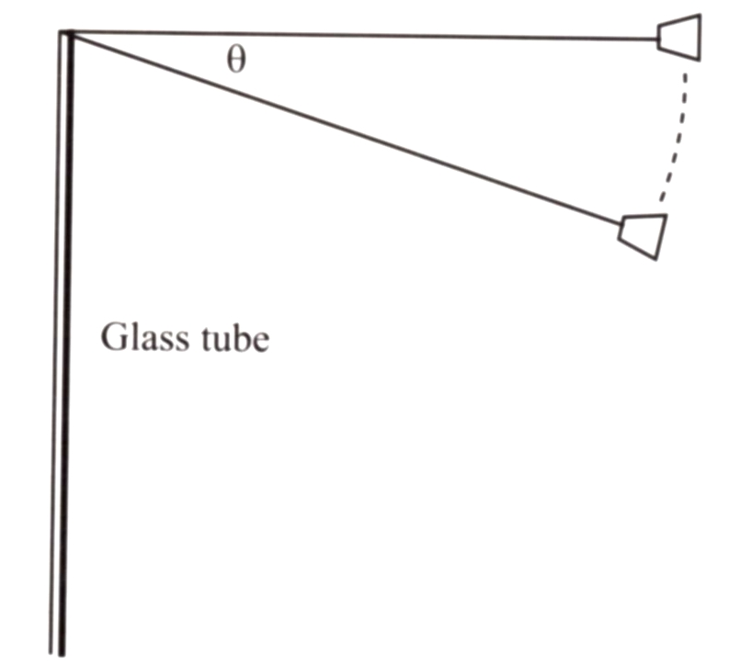
- If the string sags as shown:
Determine the expression for the component of the force which provides the centripetal acceleration.
Copper tube

F = mg
(Note: m is total mass
of suspended weights)

(1 mark)

TOTAL: 10 MARKS

